INDIAN SCHOOL AL WADI AL KABIR
TERM 1: Chapter 2- Demographic Structure of Indian Society (GRADE XII)
NOTES AND Q&A

NCERT TEXTBOOK QUESTIONS:

1.Explain the basic argument of the theory of the demographic transition. Why is the transition period associated with a ‘population explosion’?
Ans. Theory of demographic transition suggests that population growth is linked to overall levels of economic development and that every society follows a typical pattern of development related population growth.
There are three basic phases of population growth:
Stage I: Primitive Stage [Underdeveloped countries]
•Low population growth in a society that is underdeveloped and technologically backward.
•In such societies like Africa birth rate is high since people are unaware of the advantages of having small families, they are not educated.
•Death rate is also high since health and medical facilities are not available, therefore population is low.
Stage II: [Developing countries]. The birth rate and death rate rank very high, the net growth rate remains low.
Birth rate is high as in this society people live in a patriarchal society in which men decide how many children must be born and male child is preferred. People are illiterate and ignorant.
Death rate is also high since health and medical facilities are not available.
Transitional Stage: The stage between backwardness and skilled people]: In this stage growth rate of population is very high whereas death rates are brought down due to better medical facilities, nutrition and better medical and technological advancement therefore this transition period is associated with a population explosion.
Stage III: [Developed countries]. Birth rate in low because people are educated and aware and use contraceptives, birth control is popularized. Death rate is also low because of availability of health and medical facilities; therefore population is low.

2. Why did Malthus believe that catastrophic events like famines and epidemics that cause mass deaths were inevitable?
Ans. English political economist Thomas Robert Malthus argued that human population tend to grow at a much faster rates than the rate which the means of human subsistence (land, agriculture) can grow.
He said population rises in geometric progression whereas agricultural production can only grow in Arithmetic progression.
Malthus believed that positive checks to population growth in the form of famines and diseases, was inevitable. These are nature’s way of dealing with the imbalance between food supply and increasing population.
According to him, these natural checks are extremely painful and difficult. Although it helps to achieve a balance between population and subsistence by increasing the death rate.
Additional Questions: Why is the Malthusian theory criticized?

Ans:

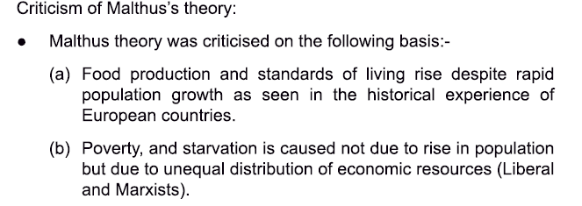

3.What is meant by ‘birth rate’ and ‘death rate*? Explain why the birth rate in relatively slow to fall while the death rate declines much faster.
Ans. Birth rate and death rate are fundamental concepts in Demography.
Birth rate: It refers to the total number of births in a particular area, which can be the entire country, a state or any territorial unit during a specific period.
•Crude birth rate in expressed through the following method : B/p x 1000
B = Number of births P = Entire population
•It is crude birth rate because it does not include the ratio of bearing age.
•Birth rate can be defined as the number of live births per thousand persons in a years.
•Birth rate gets significantly affected by Age of marriage, infertility, climatic conditions, social condition, religious beliefs and education.
Death rate: It is the number of deaths per thousands persons in a year in a particular area, which can be the entire country, a state or any other territorial unit.
Causes of slow birth rate:
Birth rate is relatively slow while the death rate can be brought down at much faster rate for the following reasons:
•Public health measures and medical advancement can control the death rate immediately. Everybody wants good health and wants to live a long life. Because of the love for life everybody adopts all medical and technological measures with high level of motivation.
Birth rate continues to be high because it is related to attitude, beliefs and values of people. Birth rate is related to religious beliefs and by and large it is socio-cultural phenomena which is significantly slow to change.

4. Which states in India have reached or are very near the ‘replacement levels’ of population growth? Which ones still have very high rates of population growth? In your opinion, what could be some of the reasons for these regional differences?
Ans. Replacement level refers to the rate of growth required for new generations to replace the older ones that are dying out.
Replacement level refers to giving birth to two children that replacement completes. States at the replacement level of population growth: Tamil Nadu, Kerala, Goa, Nagaland, Manipur, Tripura, Jammu and Kashmir and Punjab.
States very near to the replacement levels of population growth: Uttarakhand, Himachal Pradesh, Karnataka, Andhra Pradesh, Maharashtra, Arunachal Pradesh, Mizoram and West Bengal.
States having very high rates of population growth: U.P., Bihar, Rajasthan, Madhya Pradesh.
Reasons of regional differences:
•Difference in Literacy Percentage in different states.
•Societal conditions vary in different states. Terrorism, war-like conditions and insurgency in Jammu and Kashmir and North-East.
•Socio-Economic conditions vary in different states.
(i) Number of BPL people is highest among states like Uttar Pradesh, Bihar and Odisha.
(ii) Socio-cultural formation: A belief that more children means more hands to earn or religious beliefs.

5.What is meant by ‘the age structure’ of the population? Why is it relevant for economic development and growth?
Ans. •India has a very young population. The average age of an Indian is less than that for most other countries. Majority of Indians are between the age group of 15 and 64 years.
•Age structure of the population refers to the proportions of persons in different age groups relative to the total population.
•Population under the age of 15 has decreased from 42% in 1971 to 31% in 2011. During this period the ratio of age group 15 to 64 was gone up from 53% to 63.7%.
•Age structure in a country change with development of medical facilities whereas prevalence of disease reduces the life expectancy.
•Age structure of population can be put in following age groups:
0-14 years. [Children]
15-59 years. [Working population]
60 + Years. [Old people]
This age structure of the Indian population can be understood by following table.
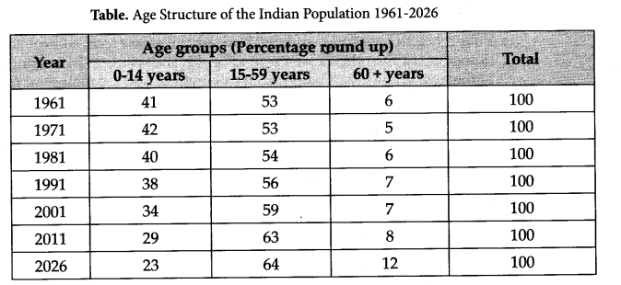
This table indicates that the share of the under 15 age group in the total population has come down from higher level of 42% in 1971 to 34% in 2001 and it is perfected to be reduced to 23% in 2026. It means birth rate in India is gradually decreasing.
Relevance for economic development and growth:
•Due to the advancement in medical sciences, public health measures and nutrition the life expectancy is at rise. This is due to economic development and growth.
•Need of family planning in being understood. Decrease in 0-14 years age group reveals that National population policy is implemented properly.
•Because of socio-cultural changes in Indian society and economic growth Age structure of population is moving towards positive young India.
•Dependency ratio is decreasing and increase in working population is causing positive growth in Indian economy.
•Economic development and improvement in quality of life improve life expectancy and changes the structures of the population.
•High infant mortality rate and material mortality rate due to poor economic growth hence an adverse effect of age structure on the population.
6.What is meant by the ‘sex ratio’? What are some of the implications of a declining sex ratio? Do you feel that parents still prefer to have sons rather than daughters? What, in your opinion, could be some of the reasons for this preference?
Ans. Sex ratio refers to the number of females per thousand males in a given area at a specified period of time.
•This ratio is an important indicator of gender balance in population.
•Historically there were more females than males in most countries of the world. This phenomenon occurred due to two reasons:
(i)Girl babies enjoy better immune system and resistant to diseases in comparison of male child.
(ii)Females live longer than males in most of the societies.
•The ratio between female babies and male babies is roughly 1050 female to 1000 male.
•In India sex ratio is declining significantly and continuously for more than a century. From 972 female per thousand males at the turn of 20th century the sex ratio declined to 933 at the turn of 21st century.
•The state level child sex ratio is alarming. As many as 6 states and union territories have a child sex ratio as low child sex ratio of 793. The highest child sex ratio of 986 is found in Sikkim.
Sex ratio seems to be declining in countries like India, China and South Korea.
In India, parents still prefer male child. This is basically due to social and cultural reasons. Being agricultural society the village population preferred male child to look after the land. The reason of preference of male child is definitely not linked with economic reasons. The states like Punjab, Haryana, Delhi, Chandigarh and Maharashtra are most prosperous states of India and should have highest child sex ratio, but things are just different.
The census of 2001 reveals that these are states with the lowest sex ratios i.e., 950 female babies per 1000 male babies. This data is a reliable evidence that selective abortion in these states is not due to poverty, ignorance or lack of resource. Predisposing factors for low child sex ratio in India:
•Religious or Cultural Beliefs: Belief that only son is entitled to perform funeral and related rituals of his parents. Only son is the waaris (heir) of family. In the absence of male child, the lineage will not continue.
•Economic Reasons: The main occupation of Indian society is agriculture. Villagers have a thinking that landed property cannot be given to girls because after marriage they will go to another village, town or city. Neither girl child can get her share of load nor she can take care of the land.
•Lack of Awareness: People in Indian society having ignorant conservation attitude are still not ready to give equal status to daughter because they think that during old age they will be dependent on the son. Only he will share food, house, customs and responsibilities.
Implications of child sex ratio: Low child sex ratio, if continues, will have serious implications on our social network, particularly the Institution of marriage. It will also cause severe law and order problem related to women.
ADDITIONAL QUESTIONS FROM SUPPORT MATERIAL
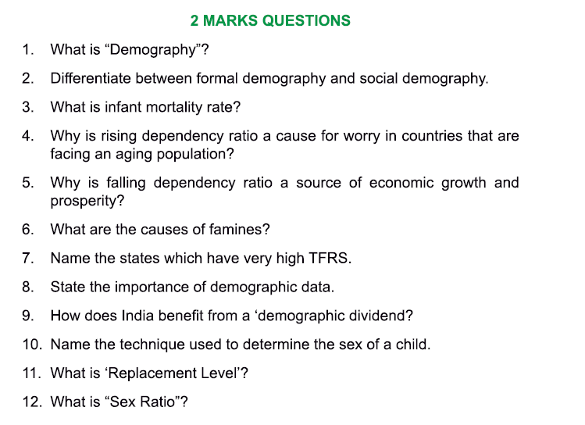
ANSWERS:
- Demography is the systematic study of the population of a country, area, community, etc. The term is of Greek origin and is composed of two words- demos (people) and graphein (describe).

- Formal Demography refers to the statistical or quantitative analysis of population which quantitatively studies events like birth, death, migration, marriage and divorce, number of males, number of females, number of youth, working population, rural- urban data. Formal demography deals with statistics, numbers, aggregates and the numerical quantification of data.

Social Demography is concerned with changes and the consequences of population growth/decline and how it affects us. In short it focuses on the birth rate, death rate and migration that happens in a particular society. Social Demography consists of four processes:
- Demographic structure: number of people in an area
- Demographic processes: birth rate, death rate, migration
- Social structure: composition of people in an area
- Social processes: processes by which individuals learn to live together in peace and harmony in society e.g. cooperation, accommodation, mediation etc.

- The Infant Mortality Rate (IMR) is the number of deaths of babies before the age of 1 year per 1000 live births.
- The dependency ratio is a measure comparing the portion of the population which is composed of dependents (i.e. elderly people who are too old to work and children who are too young to work) with the portion that is in the working age group, generally defined in the age group of 15-64 years. This ratio is usually expressed as a percentage. A rising dependency ratio is a cause of worry in many countries because these countries have a higher aging population and it is the working population who will have to carry the additional burden of supporting them.

- A falling dependency ration can be a source of economic growth and prosperity due to the larger proportion of workers relative to non-workers. This is sometimes also referred to as ‘demographic dividend’.
- During a famine there is scarcity of food or shortage of food supply and production. Famines are of two types:
- Natural: excessive rainfall, no rainfall, drought
- Manmade: excessive use of pesticides and fertilizers, lack of proper public food distribution systems.

- Total Fertility Rate (TFR)’s refers to the total number of live births that a hypothetical woman would have if she lived through the reproductive age to give birth to children all through this period. The BIMARU states namely Bihar, Madhya Pradesh, Rajasthan, Uttar Pradesh along with the newly formed states of Jharkhand and Chattisgarh have very high TFR’s in India.
- Demographic data is important for the following reasons:
- For the planning and implementation of state policies
- For overall economic development and
- General public welfare
It is interesting to note that when demographic data first emerged social statistics provided a strong justification for the new discipline of sociology.
- ‘Demographic Dividend’ or the benefit flowing from the changing age structure where the porportion of working- age people is higher that the proportion of the dependents (the young and the ageing population) in a country. However this benefit is temporary because the larger pool of working age people will eventually turn into non-working age old people. India is currently
India currently is in the second phase of demographic transition wherein its birth rate is high but the death rate is going down. And majority of its population is in the working age- group, which could be a source of economic growth. But this potential can be converted to actual growth only if the rise in the working age group is accompanied by increasing levels of education and employment.
- The technique used to determine the sex of a child is called Sonogram which is an x-ray like diagnostic device based on ultra- sound technology. Originally this was developed to identify the genetic or other disorders in the foetus, but it is also used to identify and selectively abort female foetuses.
- ‘Replacement level’ refers to the rate of growth required for new generations to replace the older ones that are dying out. When the number of people replacing the older generation is more, a country can have a situation of population explosion. Whereas when parents are replaced by two children, there is a situation of zero level of replacement.
- Sex Ratio refers to the number of females per thousand males in a given area at a specified period of time. This ratio is an important indicator of gender balance in population. Historically there were more females than males in most countries of the world.

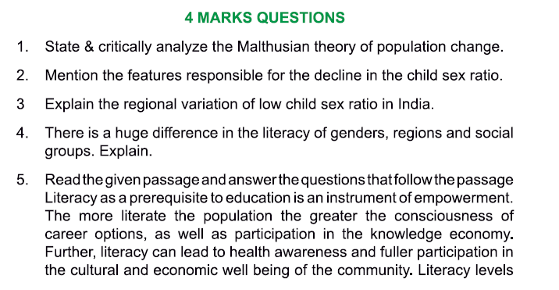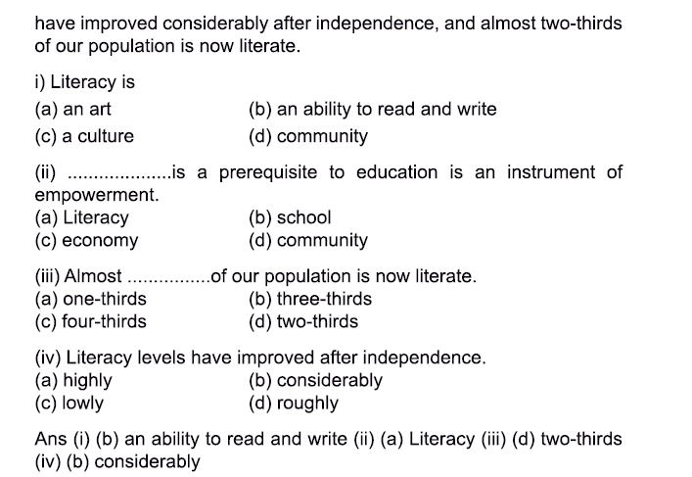
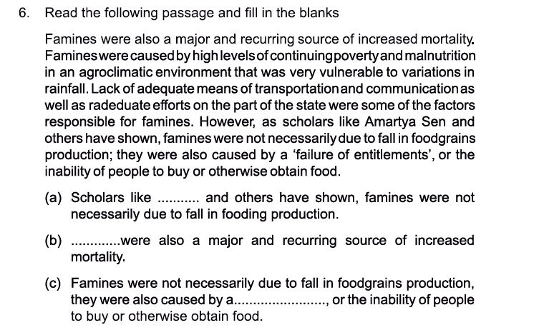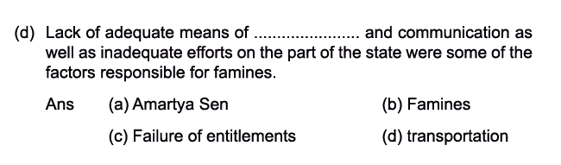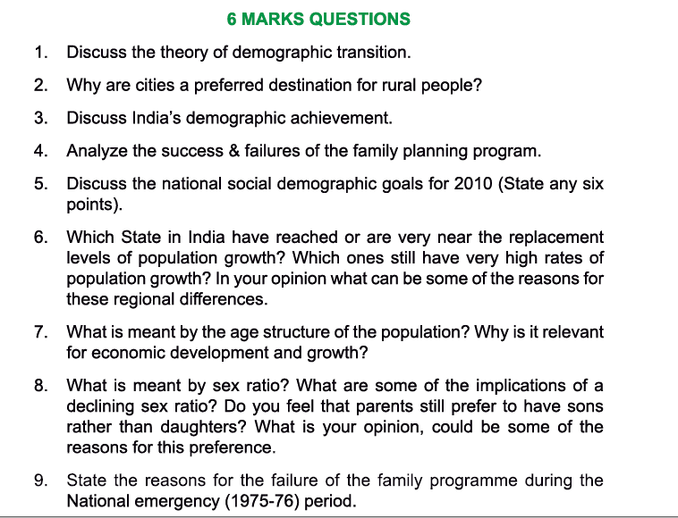
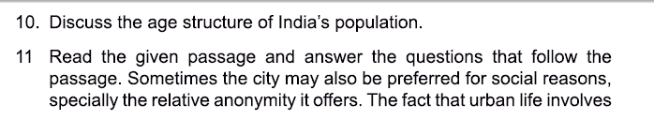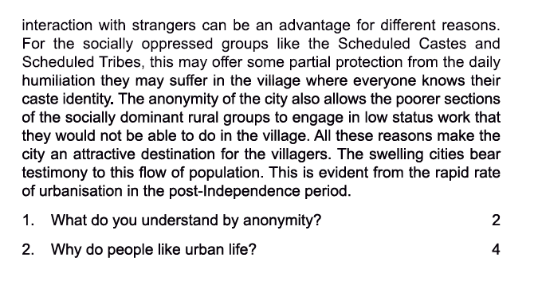
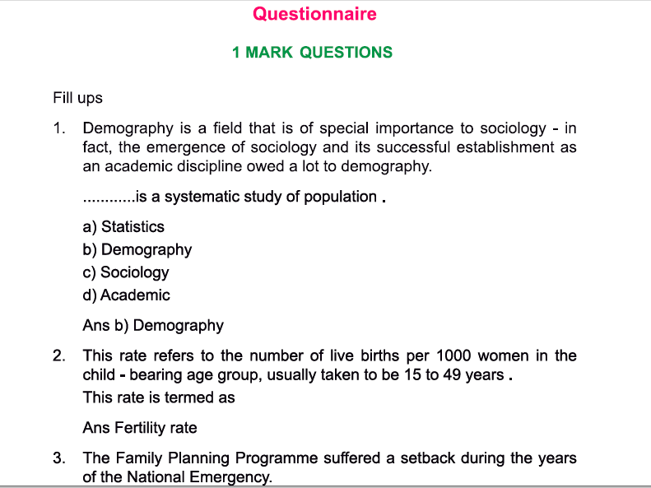
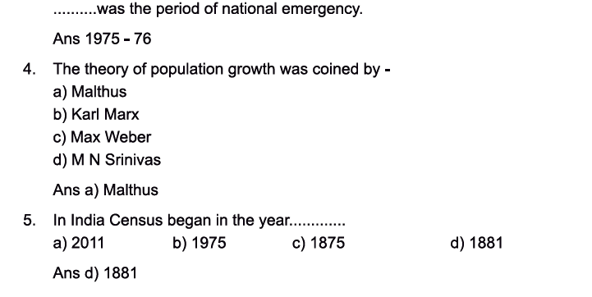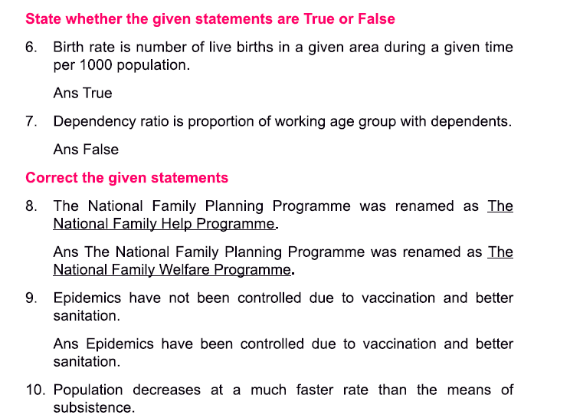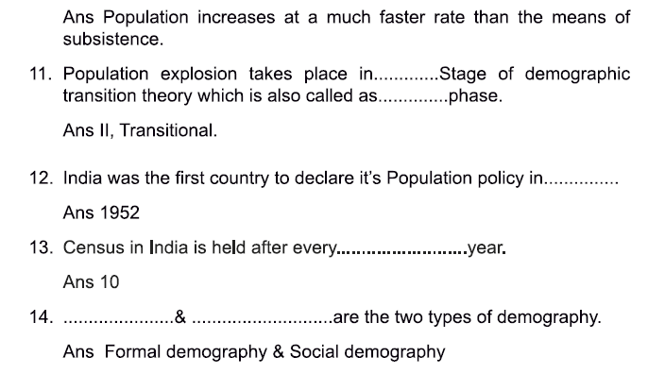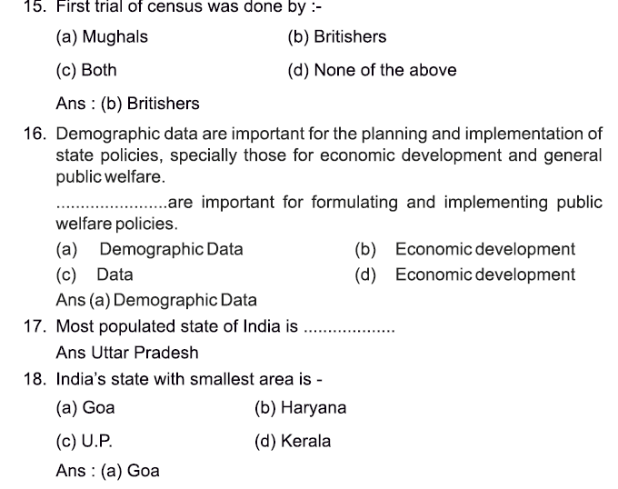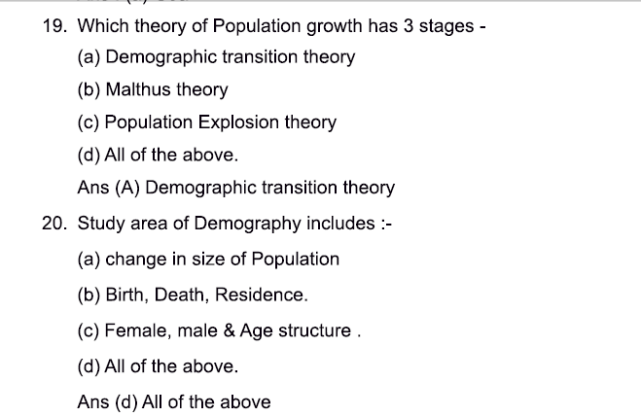
ANSWERS TO 4 MARK QUESTIONS:
2. The features/reasons responsible for the declining child sex ratio in India are as follows:
- severe neglect of girl babies in infancy leading to their death
- sex selective abortions that prevent girl babies from being born.
- female infanticide
Lowest child sex ratios are found in the most developed states of India such as Delhi, Punjab, Haryana, Gujarat which are the richest states of India with high per capita income. It is possible hat these prosperous people decide to have fewer babies, and hence decide the sex of the children which becomes possible with modern medical technology such as ultrasound.

4. Literacy is a prerequisite to education which in turn is an instrument of empowerment. In India, the literacy levels have improved considerably after independence and almost two-thirds of India’s population is now literate.
However literacy varies considerably across gender, across regions and across social groups in India. According to the census of India 2011, the literacy rate for women is 16.3% less than the literacy rate of men. However, female literacy rose by about 10.4% between 2001 and 2011 compared to the rise in male literacy of 7.6% in the same period.
Literacy rates also vary by social group- historically disadvantaged communities likethe Scheduled castes and scheduled tribes have lower rates of literacy, and the rates of female literacy within these groups are even lower.
Regional variations are still wide in India with states like Kerala approaching universal literacy, while states like Bihar are lagging far behind.
The inequalities in the literacy rate are especially important because they tend to reproduce inequality across generations.

ANSWERS TO 6 MARK QUESTIONS:
2. The vast majority of India’s population has always lived in the rural areas. According to the Census of India 2011, 68.8% population lives in rural areas while 31.2% live in urban areas. However the rate of growth of population in urban areas has been increasing steadily and the processes of modern development ensure that the economic and social significance of the agrarian-rural way of life declines relatively to the significance of urban-industrial way of life. This has been broadly true all over the world, and it is true in India as well.
Some of the reasons why cities are the preferred destination for rural people are as follows:
- The flow of rural-urban migration has been accelerated by the continuous decline of common property resources like ponds, forests and grazing lands. These common resources enable poor people to survive in the villages.
- Cities may also be preferred for social reasons, particularly the relative anonymity it offers. For e.g. SC and ST groups find protection from daily humiliation in the village where everyone knows their caste identity.
- Many poor upper caste people migrate to cities because the anonymity of the city allows them to work in jobs lower their status, which would not be possible in the village.
- Due to better connectivity- communication and transportation migration to cities has become easier.
- Younger generations have higher aspirations due to the influence of media and TV. The youth in the villages particularly get fascinated towards urban lifestyle and resources available for earning money. Growth and work opportunities are limited in the villages.
Due to all these reasons, cities are a preferred destination for rural people.
3. India’s demographic achievement since Independence

India's demographic achievements since independence :

Crude birth rate has decreased (CBR) from 40.8 (1951) to 26.4 (1998).

Halved the infant mortality rate from 146 per 1000 live births(1951) to 72 per 1000 live births (1998).

Quadrupled the couple protection rate from 10.4% (1971) to 44% (1999).

Reduced crude death rate from 25 (1951) to 9 (1998).

Added 25 years to life expectancy from 37 years to 62 years.

Reduced total fertility rate from 6 (1951) to 3.3 (1997).

4. India was the first country in the world to have launched a population policy called the National Family Planning Programme in 1952.
It’s broad objectives have remained the same – to try to influence the rate and pattern of population growth in socially desirable directions.
In the early days, the most important objective was to slow down the rate of population growth through the promotion of various birth control methods, improve public health standards, and increase public awareness about population and health issues.
Over the past half-century or so, India has many significant achievements to her credit in the field of population -
Census of India suggests that population growth is on the decline since 1991.
Fertility rate was 3.8 in 1990, and this has fallen to 2.7 today
The drop in Crude Death (CDR) and Birth Rates (CBR) for the past four decades indicates that India is progressing towards a post-transitional phase. From 1950 to 1990, the drop in CBR was less steep than the drop in the CDR. However, during 1990s, the decline in CBR has been steeper than the decline in CDR which has resulted in reduced annual population growth rate of 1.6% today.
The Family Planning Programme suffered a setback during the years of the National Emergency (1975–76).
Normal parliamentary and legal procedures were suspended during this time and special laws and ordinances issued directly by the government (without being passed by Parliament) were in force.
During this time the government tried to intensify the effort to bring down the growth rate of population by introducing a coercive programme of mass sterilisation (vasectomy for men and tubectomy for women) where vast numbers of mostly poor and powerless people were forcibly sterilised.
There was widespread popular opposition to this programme, and the new government elected after the Emergency abandoned it.
The National Family Planning Programme was renamed as the National Family Welfare Programme after the Emergency, and coercive methods were no longer used.

********************************************************

